**NAME:** ALEENA SAEED

**PROGRAM:** BSCS

**COURSE TITLE:** DATABASE SYSTEMS (LAB-1)

**SEMESTER:** 4

**SAP ID:** 56270

**TASK 1**

**task1.js**

let numbers = [1, 2, 3, 4, 5, 6];

for (let num of numbers) {

    if (num % 2 === 0) {

        console.log(num);

    }

}

**task1.html**

<!DOCTYPE html>

<html lang="en">

<head>

    <meta charset="UTF-8">

    <meta name="viewport" content="width=device-width, initial-scale=1.0">

    <title>Task 1</title>

</head>

<body>

    <script src="task1.js"></script>

</body>

</html>

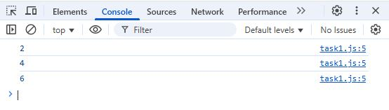**Output**

**TASK 2**

**task2.js**

let numbers = [10, 5, 8, 3, 12];

let max = numbers[0];

let min = numbers[0];

for (let num of numbers) {

    if (num > max) max = num;

    if (num < min) min = num;

}

console.log("Max:", max);

console.log("Min:", min);

**task2.html**

<!DOCTYPE html>

<html lang="en">

<head>

    <meta charset="UTF-8">

    <meta name="viewport" content="width=device-width, initial-scale=1.0">

    <title>Task 2</title>

</head>

<body>

    <script src="task2.js"></script>

</body>

</html>

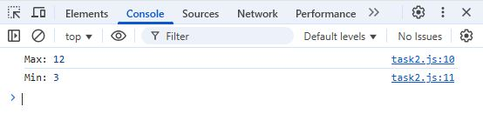**Output**

**TASK 3**

**task3.js**

let words = ["hello", "world", "javascript"];

for (let i = 0; i < words.length; i++) {

    words[i] = words[i].toUpperCase();

}

console.log(words);

**task3.html**

<!DOCTYPE html>

<html lang="en">

<head>

    <meta charset="UTF-8">

    <meta name="viewport" content="width=device-width, initial-scale=1.0">

    <title>Task 3</title>

</head>

<body>

    <script src="task3.js"></script>

</body>

</html>

**Output**

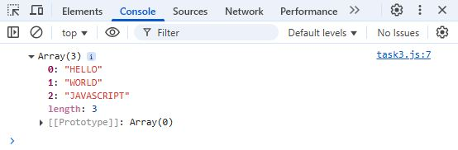

**TASK 4**

**task4.js**

let softwareHouses = ["Google", "Microsoft", "Apple", "Amazon"];

softwareHouses.shift(); // Remove first element

softwareHouses.splice(1, 1, "Netflix"); // Replace middle element

softwareHouses.push("Tesla"); // Add new element at the end

console.log(softwareHouses);

**task4.html**

<!DOCTYPE html>

<html lang="en">

<head>

    <meta charset="UTF-8">

    <meta name="viewport" content="width=device-width, initial-scale=1.0">

    <title>Task 4</title>

</head>

<body>

    <script src="task4.js"></script>

</body>

</html>

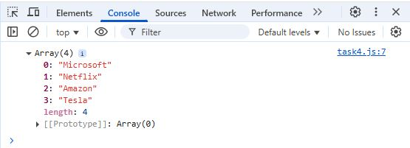**Output**

**TASK 5**

**task5.js**

function countVowels(str) {

    return str.match(/[aeiou]/gi)?.length || 0;

}

console.log(countVowels("Hello World"));

**task5.html**

<!DOCTYPE html>

<html lang="en">

<head>

    <meta charset="UTF-8">

    <meta name="viewport" content="width=device-width, initial-scale=1.0">

    <title>Task 5</title>

</head>

<body>

    <script src="task5.js"></script>

</body>

</html>

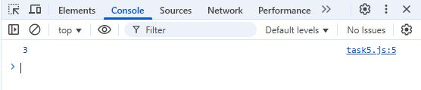**Output**

**TASK 6**

**task6.js**

let countVowels = (str) => str.match(/[aeiou]/gi)?.length || 0;

console.log(countVowels("Hello World"));

**task6.html**

<!DOCTYPE html>

<html lang="en">

<head>

    <meta charset="UTF-8">

    <meta name="viewport" content="width=device-width, initial-scale=1.0">

    <title>Task 6</title>

</head>

<body>

    <script src="task6.js"></script>

</body>

</html>

**Output**

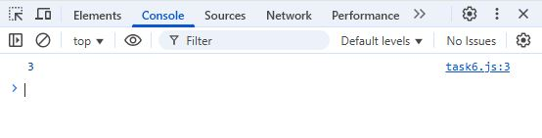

**TASK 7**

**task7.js**

let numbers = [2, 3, 4, 5];

numbers.forEach(num => console.log(num * num));

**task7.html**

<!DOCTYPE html>

<html lang="en">

<head>

    <meta charset="UTF-8">

    <meta name="viewport" content="width=device-width, initial-scale=1.0">

    <title>Task 7</title>

</head>

<body>

    <script src="task7.js"></script>

</body>

</html>

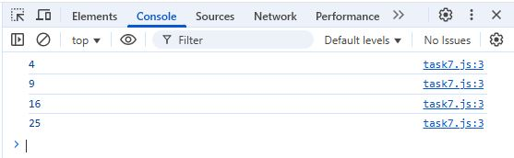**Output**

**TASK 8**

**task8.js**

let marks = [45, 60, 30, 75, 50];

let highMarks = marks.filter(mark => mark > 50);

console.log(highMarks);

**task8.html**

<!DOCTYPE html>

<html lang="en">

<head>

    <meta charset="UTF-8">

    <meta name="viewport" content="width=device-width, initial-scale=1.0">

    <title>Task 8</title>

</head>

<body>

    <script src="task8.js"></script>

</body>

</html>

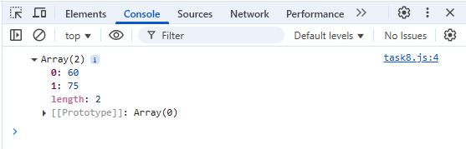**Output**

**TASK 9**

**task9.js**

let n = parseInt(prompt("Enter a number:"));

let numbers = Array.from({ length: n }, (_, i) => i + 1);

console.log(numbers);

**task9.html**

<!DOCTYPE html>

<html lang="en">

<head>

    <meta charset="UTF-8">

    <meta name="viewport" content="width=device-width, initial-scale=1.0">

    <title>Task 9</title>

</head>

<body>

    <script src="task9.js"></script>

</body>

</html>

**Output**

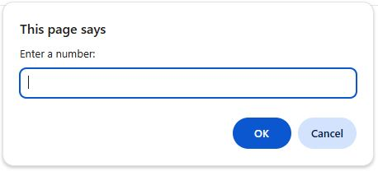

**TASK 10**

**task10.js**

let numbers = [2, 3, 4, 5];

let product = numbers.reduce((acc, num) => acc * num, 1);

console.log("Product:", product);

**task10.html**

<!DOCTYPE html>

<html lang="en">

<head>

    <meta charset="UTF-8">

    <meta name="viewport" content="width=device-width, initial-scale=1.0">

    <title>Task 10</title>

</head>

<body>

    <script src="task10.js"></script>

</body>

</html>

**Output**

